PopUp GUI (PUG) Users Manual

Scott Jewell

Pacific Marine Environmental Laboratory

Version 1.1

6/14/2022

**Startup**

1. If there is not a calibration spreadsheet previously stored, the program will open with a file dialog to load one.
2. If it cannot find a calibration binary it will ask the user to load data from a spreadsheet
   1. The GUI will then attempt to create a binary containing the calibration data for future use
   2. If it cannot create this repository, the user will have to manually load the data upon each startup

**Basic Info Tab**

* **Header ID:** Unique identifier for each PopUp. Four alphanumeric characters
* **Phone #**: Satellite telephone number. 11 numeric digits.
* **Release Date**: Date of configuration release. DD/MM/YY date stamp.
* **Configuration Write Location**: This allows the user to write input information into a configuration .txt file. This .txt file can be manually loaded into a PopUp using a terminal
* **Import Existing Configuration File:** Allows the user to select a pre-existing configuration .txt file. This will populate all the text fields and import calibration data.

**Sampling Tab**

* **GPS:**
  + **Start:** Date when GPS will start recording. HH:MM:SS timestamp.
  + **Interval**: Interval at which GPS will start recording. HH:MM:SS timestamp
* **Under Ice:**
  + **Start:** HH:MM:SS timestamp. Used to determine the start and frequently of under ice data recording
  + **Interval**: HH:MM:SS timestamp
* **Bottom:**
  + **Start:** HH:MM:SS timestamp. Used to determine the start and frequently of ocean-bottom data recording.
  + **Interval**: HH:MM:SS timestamp
* **Iridium:**
  + **Start:** Date when PopUp will start sending data packages. HH:MM:SS timestamp.
  + **Interval**: Interval at which PopUp will send data packages. HH:MM:SS timestamp
* **SST:**
  + **Start:**  HH:MM:SS timestamp.
  + **Interval**: HH:MM:SS timestamp

**Calibrations Tab**

* **Thermometer #1:** Select thermometer instrument number and the PUG will add calibration information pulled from the calibration spreadsheet.
* **Thermometer #2:** Select thermometer instrument number and the PUG will add calibration information pulled from the calibration spreadsheet.
* **Depth Sensor:** Select pressure sensor number and the PUG will add calibration information pulled from the calibration spreadsheet.
* **Import New Calibration File:** Select

**Serial I/O Tab**

* **Active COM Port**: Lists all active serials ports on computer, select the one connected to the PopUp
  + Note: The PUG cannot identify PopUp, you will need to use the device manager to find which COM port your PopUp is connected to.
  + Note: Windows 10 users will need to check that they have a COM driver installed
  1. To do so, go to Device Manager.
  2. Ensure that “Ports (COM & LPT)” exists.

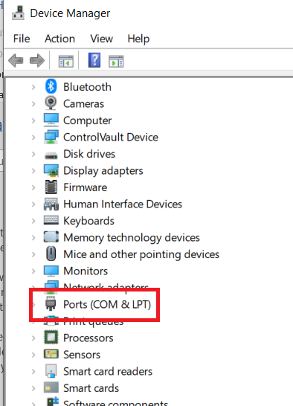

* 1. If they do not, you will need to install drivers
     1. This can be done using the “Action” menu and “Install Legacy Hardware”
     2. Or installing an UART driver, such as those at <https://ftdichip.com/drivers/>, will also work
* **Refresh:** Used to refresh the COM port list. You will need to refresh the list if you plug in your PopUp after launching the PUG
* **Read Config:** This will read the current config loaded on the PopUp.
  + Note: This does not work reliable twice in a row, so you may need to press multiple times or restart the program.
* **Write Config**: Will write current values to the PopUp as a config. If values are missing or malformed an error message will appear.
  + Note: Using this repeatedly is not reliable and not recommended. Please restart the PUG every time you want to write a new config.

**User Inputs**

1. Type in inputs using keyboard key inputs
2. PUG will popup warning messages if data is input incorrectly (see section ### for formatting)
3. Dates and times will have delimiting characters (“/” and “:” respectively) added automatically.
4. All inputs must be filled prior to writing, program will warn the user if there is missing information

**Importing and Exporting Configs**

1. Configuration text files can be import using the “Import” command on the Basic Info. This will populate textboxes
2. Configurations can be written by pasting a path to the “Configuration Write Location” or clicking the “...” button to define a path. The configuration will then be read in by pressing the “Write Configuration” button. .

**Calibration Files**

1. Calibration files can be imported on the calibration tab.
2. The PUG will automatically generate a binary of the calibration data and store it so that calibration files only need to be loaded when new calibration data is added.
3. Format of calibration file is included in the appendix

**Serial I/O Functions**

1. Plug in USB cable to PopUp float
2. Find COM port that is active
3. Either start the PopUp GUI program or press the “Refresh” button on the Serial I/O tab to updated the list of available COM ports
4. Reading a config will pop up a window with the current configuration information from the PopUp
5. Write config will push the information currently populating the text boxes to the PopUp.
   1. If there is information missing, a message will pop listing the missing information.

**Appendix A: Configuration template**

Below is a configuration template with filler characters. Note that various functions use the opening “MASTER” and tailing “~” as beginning and ending characters; omitting them will create unexpected behavior of both PopUps and the PUG. Normally invisible endline characters (\r\n) have been omitted.

MASTER

headerid=NNNN

phone=XXXXXXXXXXX

release=MM/DD/YY

gps

samplestart=HH:MM:SS

sampleinterval=HH:MM:SS

under_ice

samplestart=HH:MM:SS

sampleinterval=HH:MM:SS

iridium_tx

samplestart=HH:MM:SS

sampleinterval=HH:MM:SS

bottom_sample

samplestart=HH:MM:SS

sampleinterval=HH:MM:SS

sst_sample

samplestart=HH:MM:SS

sampleinterval=HH:MM:SS

pressure S/N: XXXX

cal=X.XXXXXXXXX,X.XXXXXXXXX

probe1 S/N: NNNN

c1=X.XXXXXXXXXXXXXXXXXXX,c2=X.XXXXXXXXXXXXXXXXXXX,c3=X.XXXXXXXXXXXXXXXXXXXXX

probe2 S/N: NNNN

c1=0.0010487040596532700,c2=X.XXXXXXXXXXXXXXXXXXX,c3=X.XXXXXXXXXXXXXXXXXXXXX

~

**Appendix B: Calibration File Format**

Tab: Temp CAL DATA



Tab: Pres CAL DATA

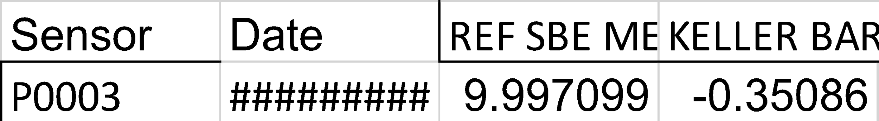

**Appendix C: Known Issues**

Attempting to read configurations twice in a row via serial will result in an empty message. Should work correctly if tried again

Sometimes PUG will become trapped in an endless communications loop while attempting to connect to a PopUp. Program should be terminated and PopUp restarted before attempting to read or write.

Program often will not work correctly if trying to write a configuration via serial twice. If you want to write the same configuration multiple times, restarting the program is advised.

Serial status doesn’t display messages when it should.